**Name: Ankan Kumar Daw (22234030350)**

**Subject : Discrete Structure Lab**

**Assignment 1**

**1.Write a program to rotate an array of n integers by d time rotation. The N=10 and d is user input Rotation is circular right to left**

#include <stdio.h>

void rotateArray(int arr[], int n, int d)

{

int temp;

for (int i = 0; i < d; i++)

{

temp = arr[0]; // Store the first element

for (int j = 0; j < n - 1; j++)

{

arr[j] = arr[j + 1]; // Shift elements to the left

}

arr[n - 1] = temp; // Place the first element at the end ...as we are shifting from right to left

}

}

int main()

{

int n, d;

printf("Enter the size of the array: ");

scanf("%d", &n);

int arr[n]; // Declare the array after reading n

printf("Enter the elements:\n");

for (int i = 0; i < n; i++)

{

scanf("%d", &arr[i]);

}

printf("Enter the number of rotations: ");

scanf("%d", &d);

rotateArray(arr, n, d);

printf("\nRotated array is : ");

for (int i = 0; i < n; i++)

{

printf("%d ", arr[i]);

}

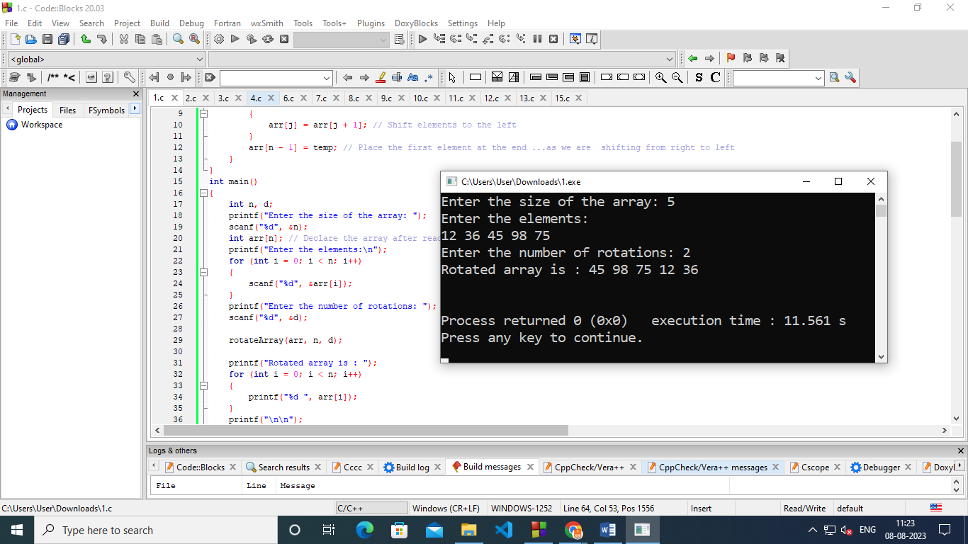 return 0;

}

**2.Write a program to reverse the array of N integers .Take n=10 and the elements are user input**

//reverse array of n integers;n=10

#include<stdio.h>

#include<conio.h>

void main()

{

int arr[100],i,n;

printf("enter the Size :");

scanf("%d",&n);

printf("\nEnter the numbers ");

for(i=0;i<n;i++)

{

scanf("%d",&arr[i]);

}

printf("\nThe reversed array is ");

for(i=n-1;i>=0;i--)

{

printf("%d ",arr[i]);

}

getch();

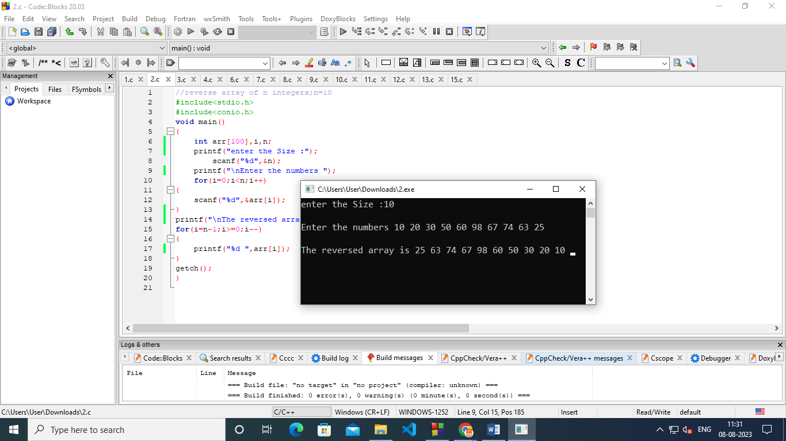}

3.Write a program to delete an array element and display the array